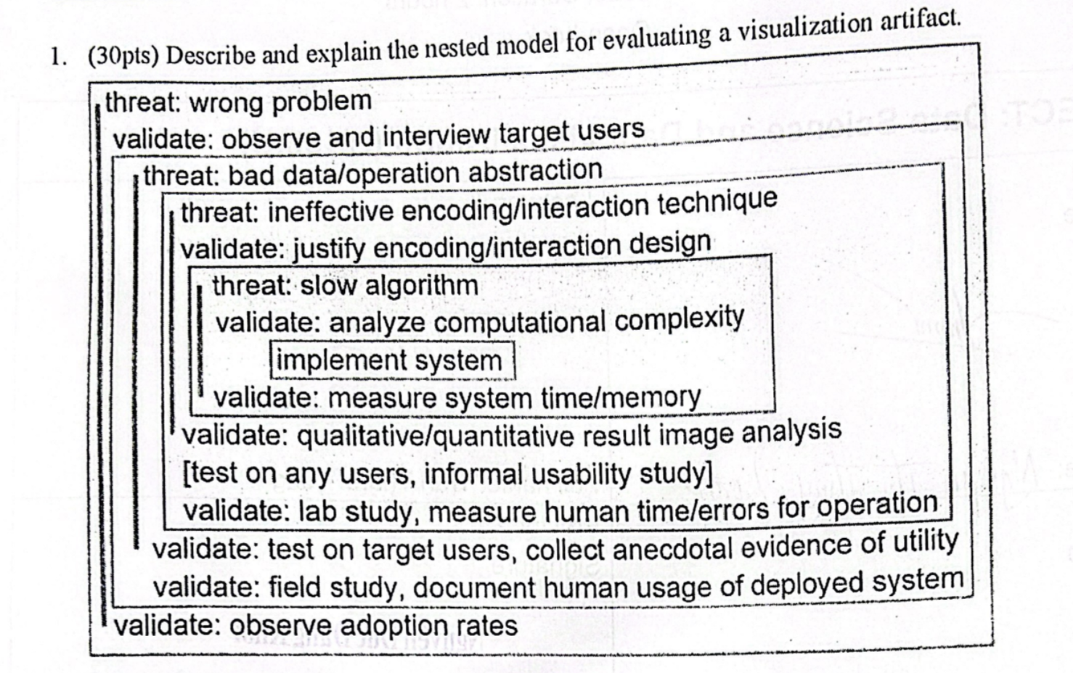

The nested model:

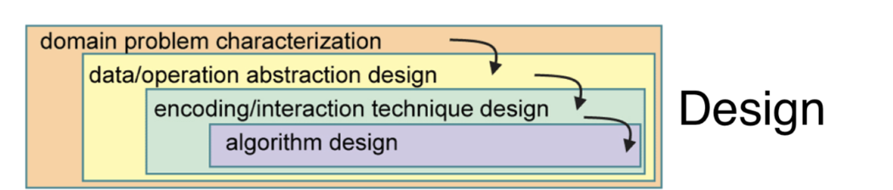

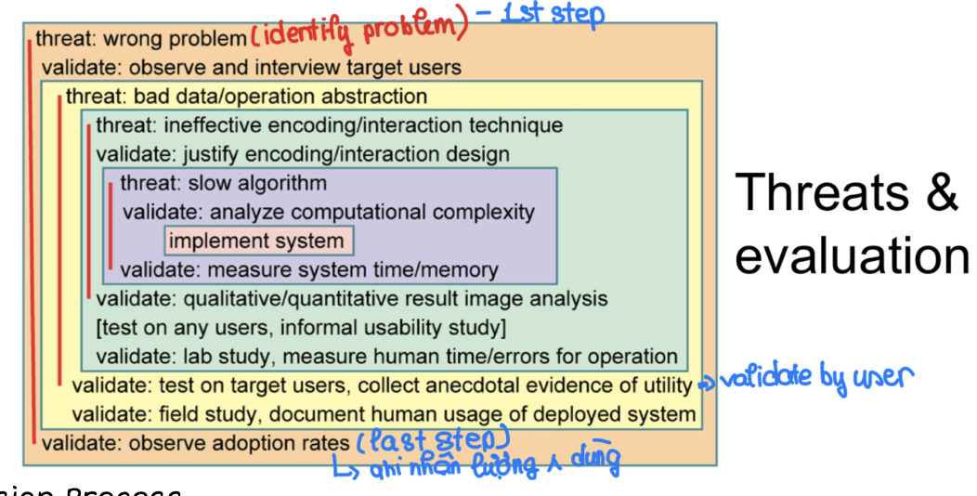

Design process:

- The nested model for evaluating a visualization artifact, as shown in the image, is a framework designed to assess various aspects of a visualization tool or system.

- This model is hierarchical and addresses potential threats at each stage of system development and deployment, offering validation methods to ensure the effectiveness and efficiency of the visualization.

**Here is an explanation of each level:**

1. Threat: Wrong Problem

* Validate: To mitigate the threat of solving the wrong problem, the model suggests observing and interviewing target users to understand their needs and validate that the visualization addresses the correct issues.

2. Threat: Bad Data/Operation Abstraction

* Validate: When there is a threat of the visualization being based on poor data or incorrect abstraction of operations, the model recommends justifying the encoding and interaction design to validate that the data and operations abstracted are appropriate and meaningful.

3. Threat: Ineffective Encoding/Interaction Technique

* Validate: To counter the threat of ineffective visual encoding or interaction techniques, one should justify the chosen encoding and interaction design. This process ensures that the methods used for representing and interacting with data are effective and support the intended tasks.

4. Threat: Slow Algorithm

* Validate: A slow algorithm can significantly hamper the performance of a visualization tool. Analyzing computational complexity helps validate the efficiency of the algorithm and ensures that it is fast enough for practical use.

5. Implement System

* This is the stage where the actual development and implementation of the visualization system take place.

6. Validate: Multiple validation steps are proposed post-implementation:

* Measure System Time/Memory: Evaluate the performance of the system in terms of speed and resource usage.
* Qualitative/Quantitative Result Image Analysis: Analyze the output images both qualitatively and quantitatively to ensure they convey the intended information effectively.

7. Test on Any Users, Informal Usability Study

* Validate: Conducting lab studies or informal usability studies with any users (not necessarily the target audience) helps to measure human time and errors for operation, providing initial insights into the system’s usability.

8. Test on Target Users, Collect Anecdotal Evidence of Utility

* Validate: Testing the system on target users and collecting anecdotal evidence of its utility ensures that the system is useful for its intended audience.

9. Field Study, Document Human Usage of Deployed System

* Validate: Conducting a field study and documenting how humans use the deployed system in real-world scenarios provides deeper insights into its effectiveness and areas for improvement.

10. Observe Adoption Rates

* Validate: Finally, observing the adoption rates of the system can serve as a validation of its overall success and impact on the target user group.

**Question 2:**

[**https://vnexpress.net/dong-tien-hoi-lo-chuyen-bay-giai-cuu-4594645.html**](https://vnexpress.net/dong-tien-hoi-lo-chuyen-bay-giai-cuu-4594645.html)

1. **Which storytelling genre is used in the article? (5 marks)**

- The article from VnExpress is an investigative piece, uncovering the corruption and bribery involved in the organization of "rescue flights" during the COVID-19 pandemic. This kind of storytelling falls under the genre of investigative journalism. It provides a detailed account of how businesses and officials exploited a government policy intended to repatriate citizens during the pandemic, turning it into a profitable scheme through bribes and corruption. The narrative is structured to expose the illicit activities and the network of individuals involved, using evidence and factual information collected during the investigation.

1. **What are the goals of the use of charts and interactive charts? What could be the problem if there are no charts in the article. (10 marks)**

- Simplify complex information: Charts can distill complex data into an easy-to-understand visual format.

- Enhance engagement: Interactive charts encourage reader interaction, increasing engagement with the content.

- Facilitate better understanding: Visuals can help readers quickly grasp trends, patterns, and outliers in data.

- Support storytelling: Charts can serve as visual evidence that supports the narrative of the article.

- Encourage memory retention: Visual data representations can be more memorable than text-based descriptions.

**Without charts, readers might face difficulties in:**

* Understanding complex data or statistical information.
* Staying engaged, especially if the article is data-heavy.
* Visualizing the information the article is trying to convey, which might lead to misinterpretation or a lack of interest.

1. Analyze the chart "Đường dây nhận hối lộ từ các doanh nghiệp đến 21 bị can ở 5 Bộ, VPCP và 2 địa phương"

**• What is input data? (5 marks)**

* The input data for this chart would include:
* The identities of the 21 suspects (bị can) implicated in the case.
* The five ministries involved in the alleged corruption network.
* The relationships between the individuals and the entities.
* The amounts of money involved in the bribery, possibly detailed per individual or entity.
* The roles of the suspects such as who offered the bribe (đưa hối lộ), who received the bribe (nhận hối lộ), any middlemen (môi giới hối lộ), and any instances of fraud (lừa đảo chiếm đoạt tài sản).

**• Which marks and channels are used to visualize the data? (10 marks)**

* Marks: These are the elements that represent the data points. In the chart, marks include:
* Circles: representing individuals or entities involved in the bribery network.
* Lines or connectors: indicating relationships or transactions between the individuals and entities.
* The channels used include:
* Position: the spatial placement of the marks to show the connections and the hierarchy within the network.
* Size: the size of the circles likely represents the amount of money involved in the bribery.
* Color: used to differentiate the roles of the participants (e.g., who gave bribes, who received them, intermediaries, etc.).
* Opacity: may be used to indicate the level of involvement or certainty in the data about a particular individual or entity

**• What is the goal of the chart in terms of task abstraction in visualization? (10 marks)**

* Data Correlation: The visualization correlates individuals with monetary amounts, indicating who received or gave bribes, and possibly their role in the network (e.g., giver, receiver, broker).
* Highlighting Extremes: The chart highlights the extremes in the dataset, such as the largest and smallest bribes. => To allow viewers to compare the extent of involvement among individuals or entities.
* Educational Tool: It likely serves as an educational tool to inform the public or stakeholders about the extent of corruption within these institutions.
* Analytical Overview: The visualization provides an analytical overview of the bribery network, which can be used for further analysis or reporting.
* Investigation Aid: For investigative purposes, such a chart could help in identifying key players and understanding the flow of illicit funds.

**Question 3:** Design a visualization

In a university, the curriculum of a program is updated each year such as

- Add new courses

- Remove existing courses

- Move a course from one semester to another

- Add a new connection between two courses

- Remove an existing connection between two courses

The update is to adopt new knowledge and technology, but people need to track the differences between versions.

Design a visualization to compare two versions of a curriculum.

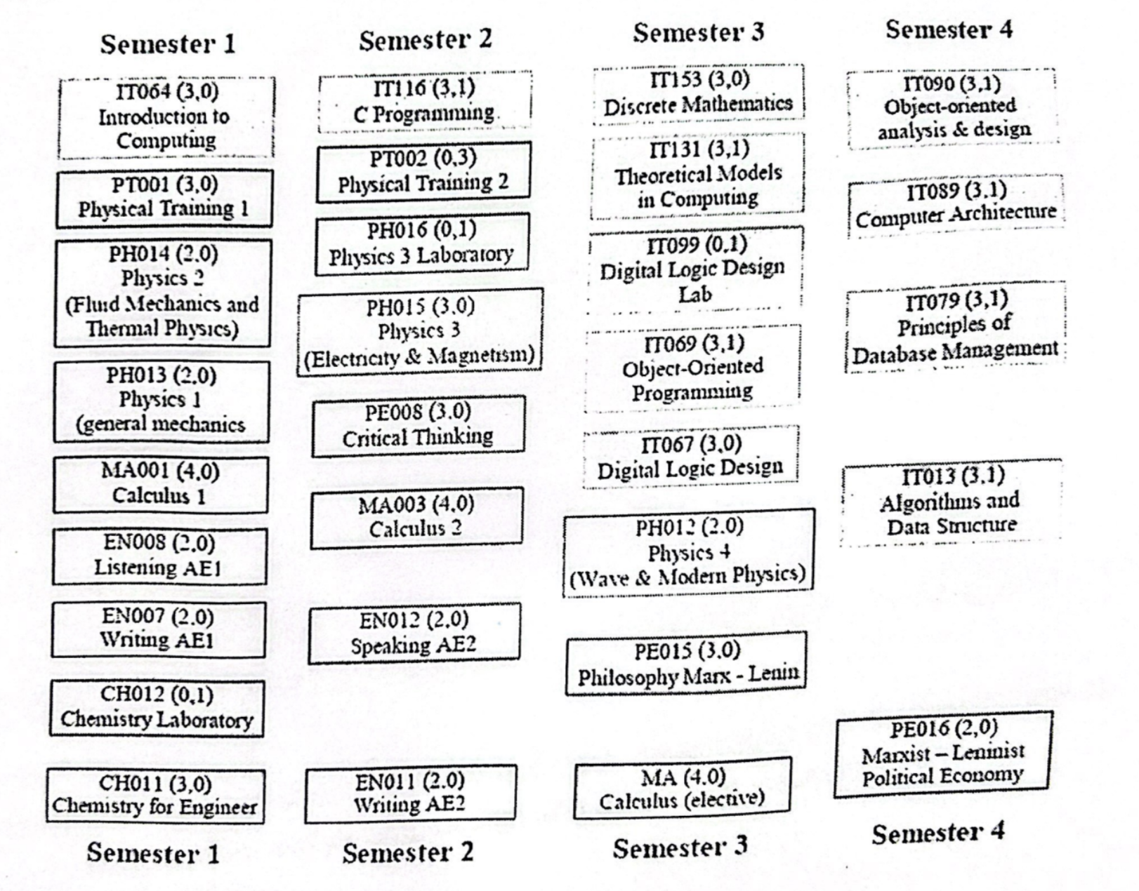

- Color Coding: Different colors to represent courses that are new, removed, or unchanged. For example, green for new courses, red for removed courses, and blue for unchanged courses.

- Lines and Arrows: Use solid lines to connect related courses that are prerequisites or corequisites. Dashed lines could indicate connections that have been removed.

- Layout: Position courses in a grid according to the semester they are offered. This allows for easy comparison of which semester a course is moved to or from.

- Annotations: Use annotations or side notes to indicate significant changes, like if a course has been significantly updated in terms of content.

- Interactive Elements: If the visualization is digital, interactive elements can allow users to hover over or click on courses to see detailed changes, like the syllabus or credit hours.

- Version Toggle: Include a toggle switch or slider to move between the old and new curriculum versions for a direct comparison.

- Summary Section: Provide a summary box that lists the number of courses added, removed, and changed.

- Filter Options: Give users the ability to filter the visualization by category (e.g., new, removed, unchanged, moved).